less Data2-T

his command is used to load a single page from the file.

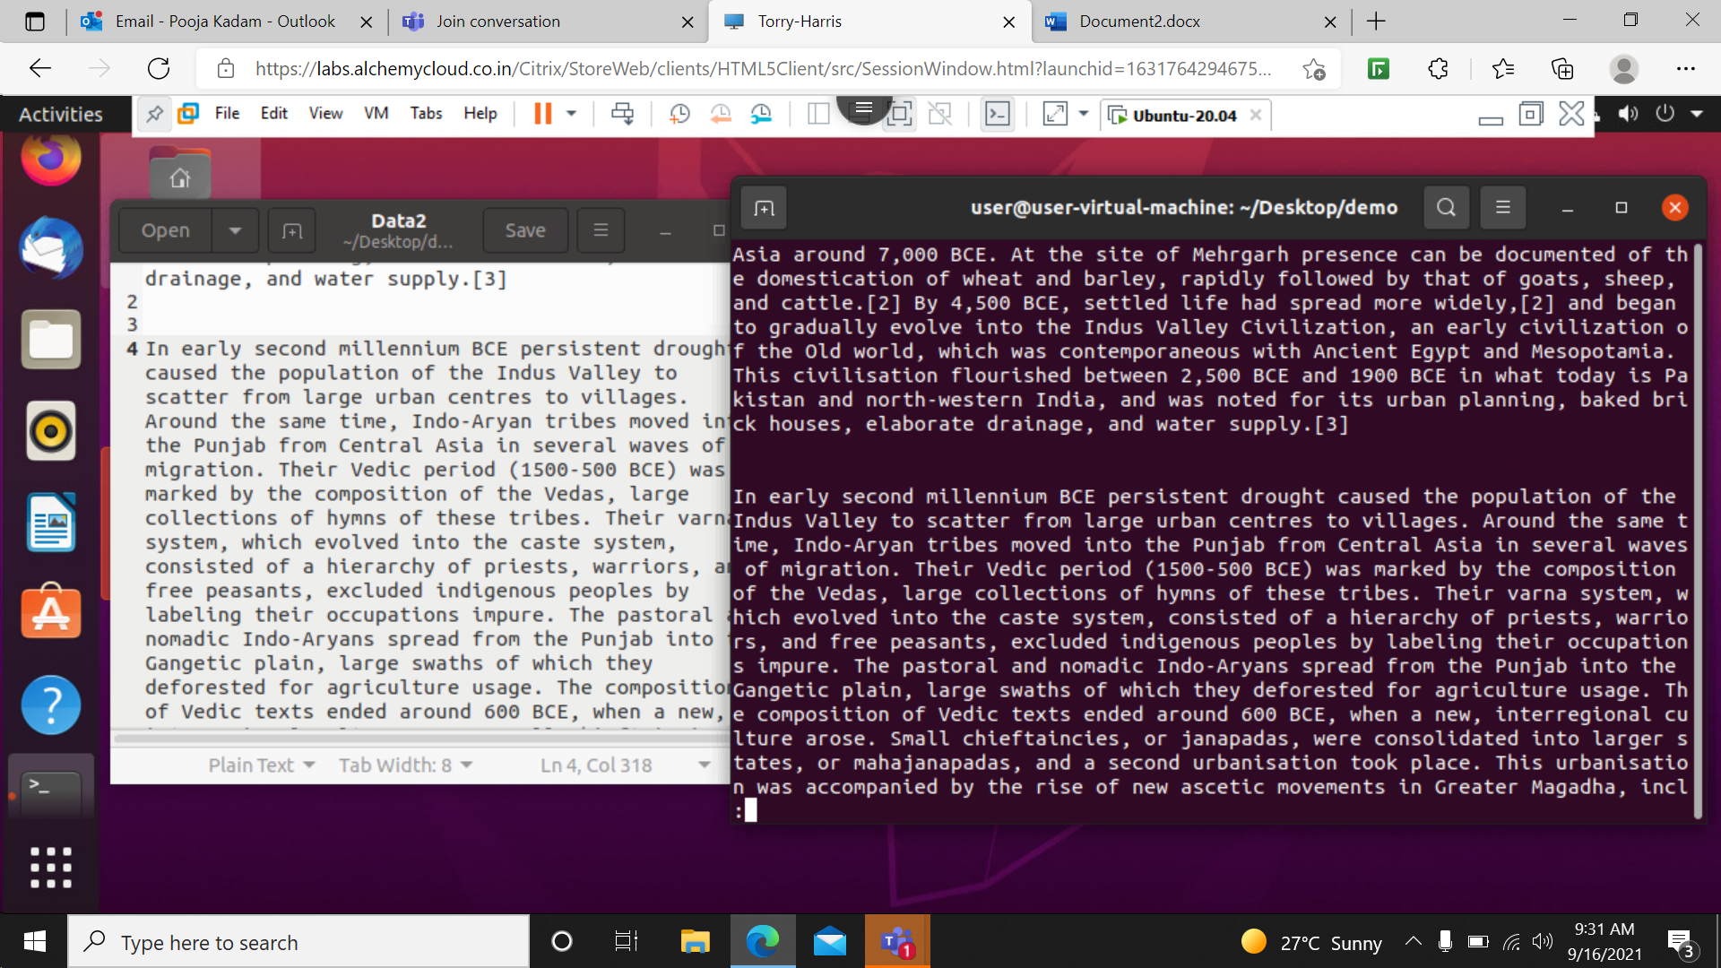

less –p ‘indus‘ Data2- This command is used to check particular word in the first page of that file.

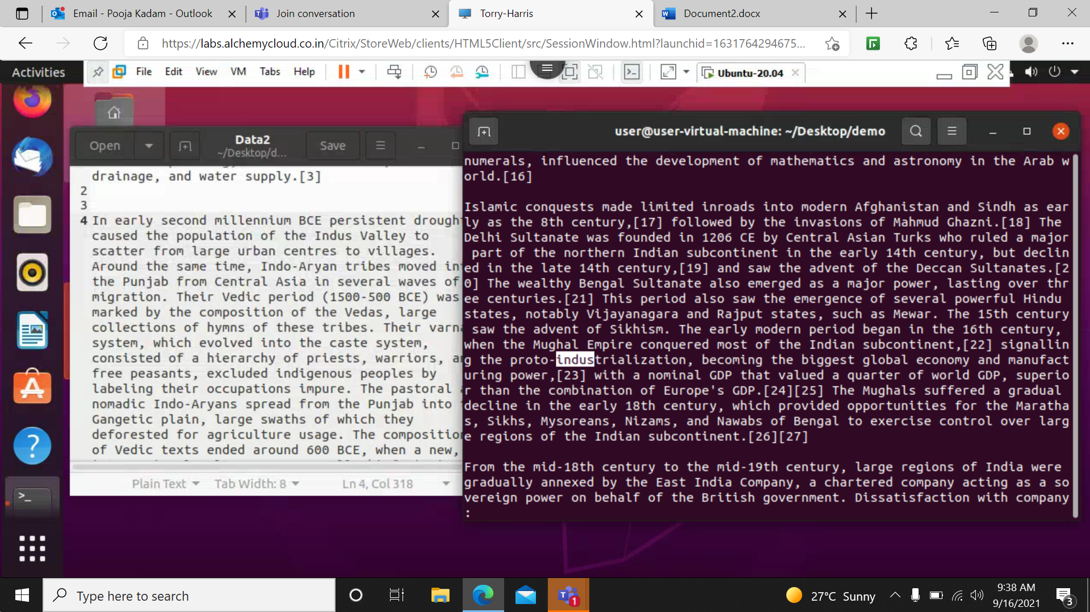

less -N Data2 – This command is used to show the line number in the file.

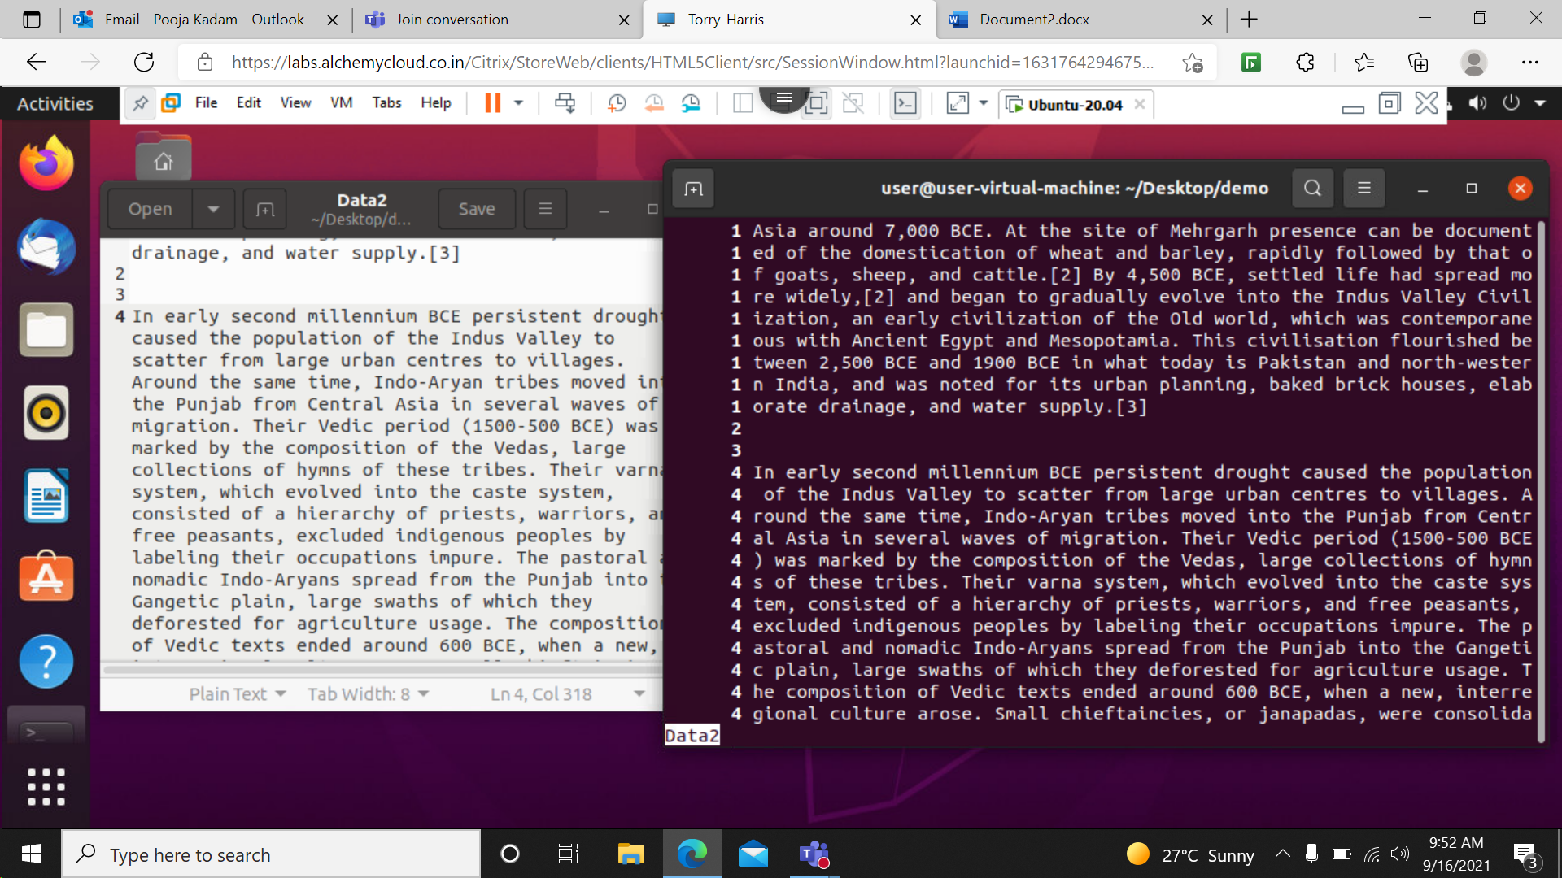

vim- By typing vim in the terminal it shows all the command that used to download the vim in the system with version.

Copy the command and paste that command in the command line and the enter then give your system password then all packages need to run vin got installed in the system.

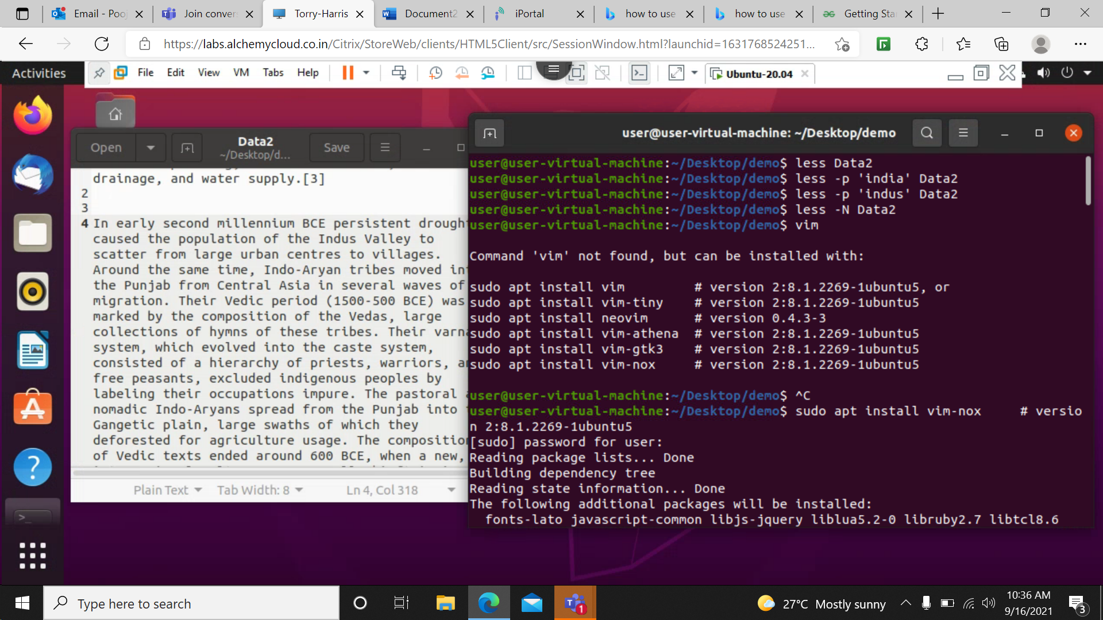

vim new – This command is use to create a new txt file with name new.

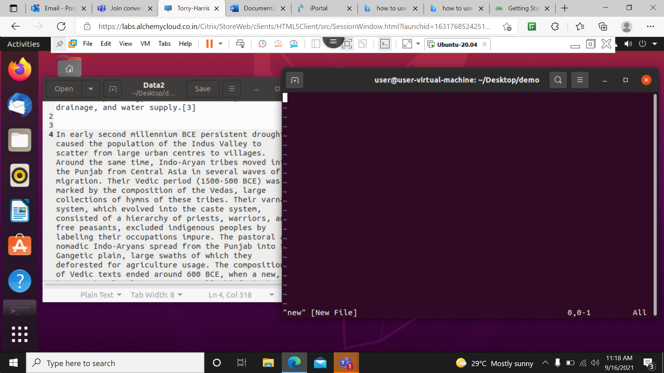

:q!- this command is used to quit from the current window of the file

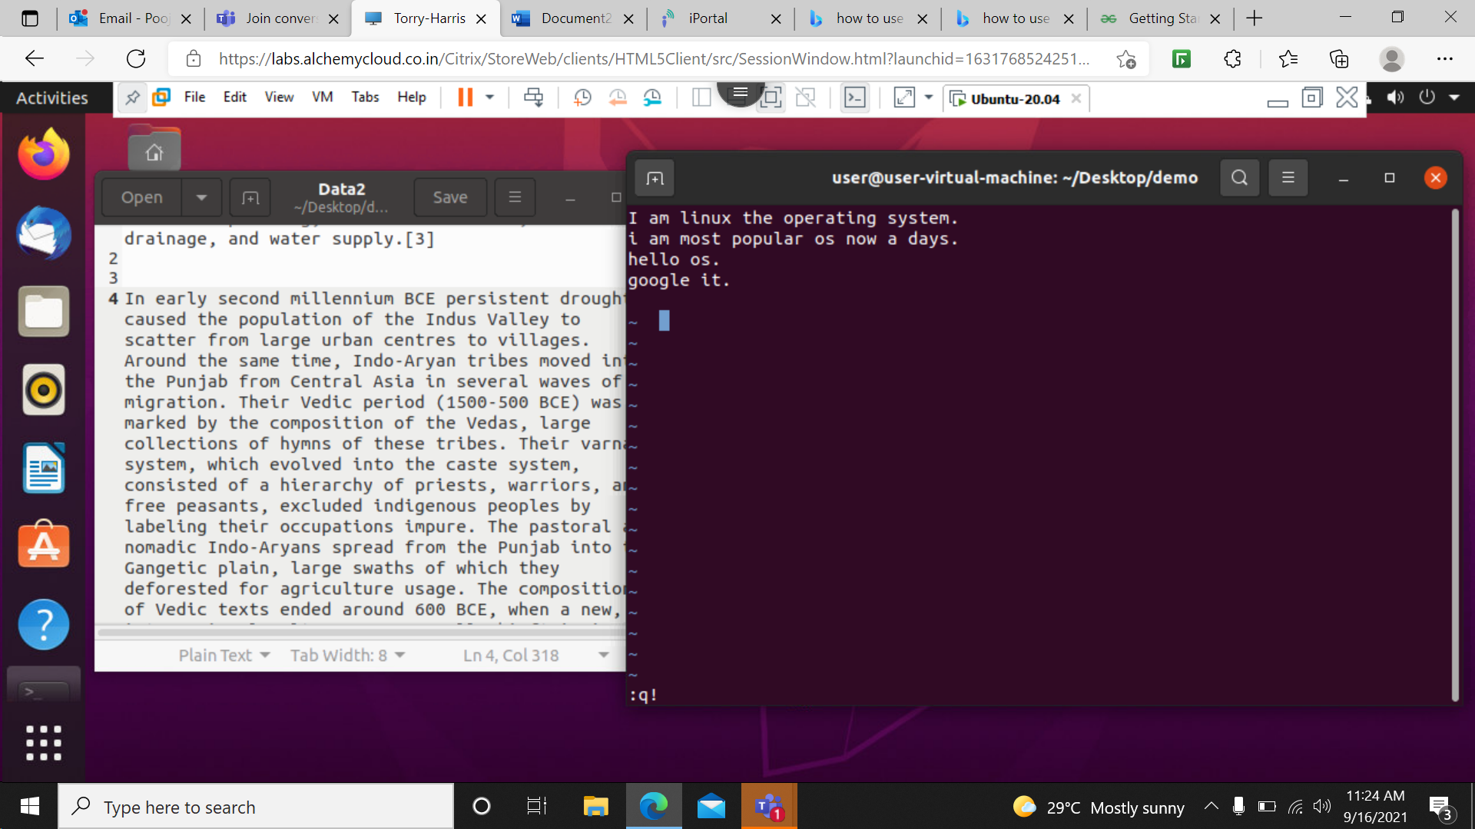

:wq- This command is used to save the file as well as meanwhile we get out of the file on the terminal.

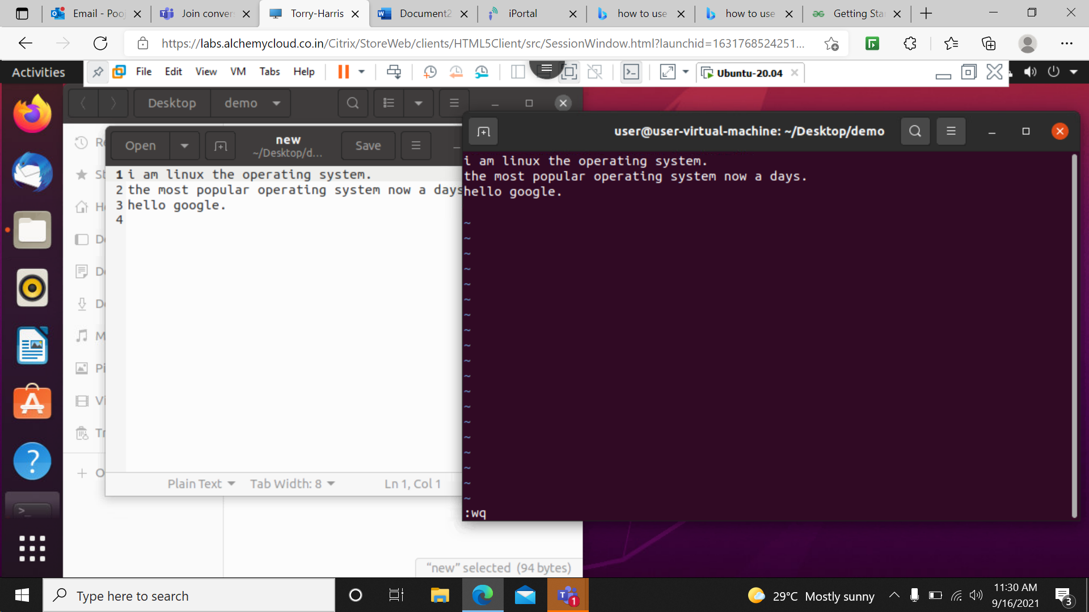

:r data- This command is used to read the the content of the file named as data.

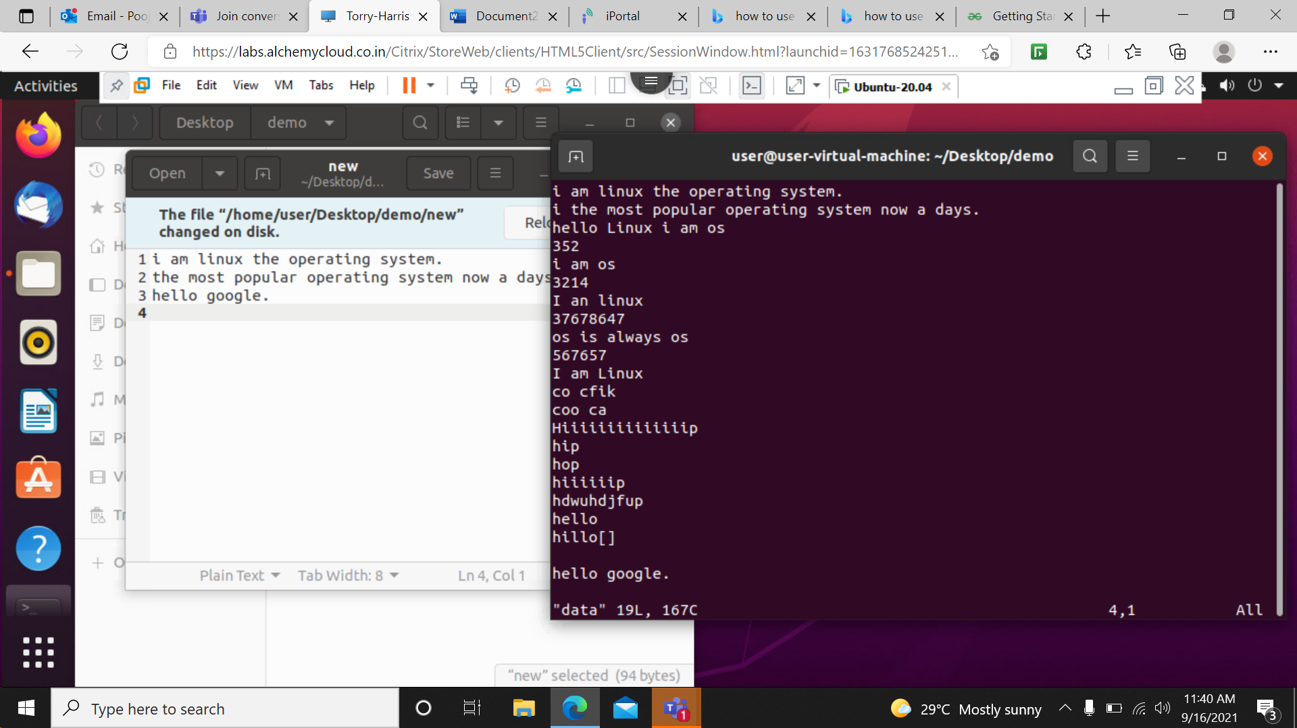

:w- this command is use to save the contents of the file.

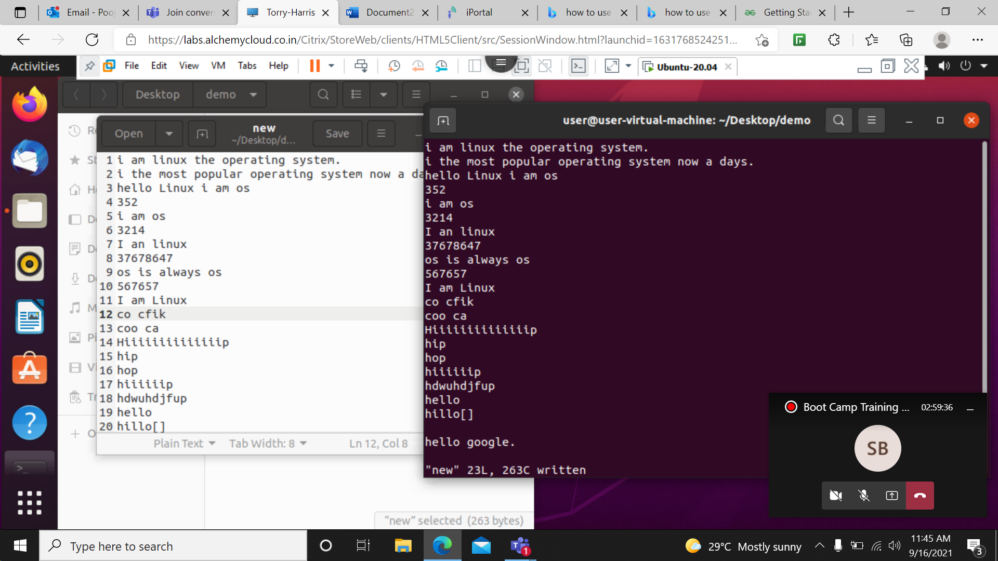

head –n 3 data- This command is used to print the data of the file named data upto first 3 lines of the file from starting .

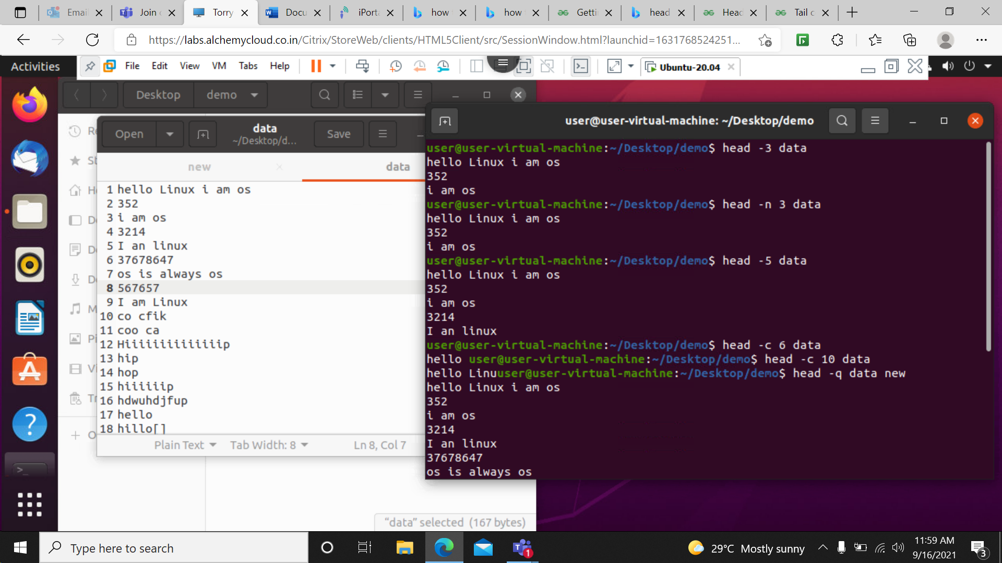

head –c 6 data- This command is used to print first 6 bytes if the line in the file named as data from starting.



head –q data new –This command is used to print the text inside the files named as data and new from starting.



head –v data- This command is use to print the name of the file.

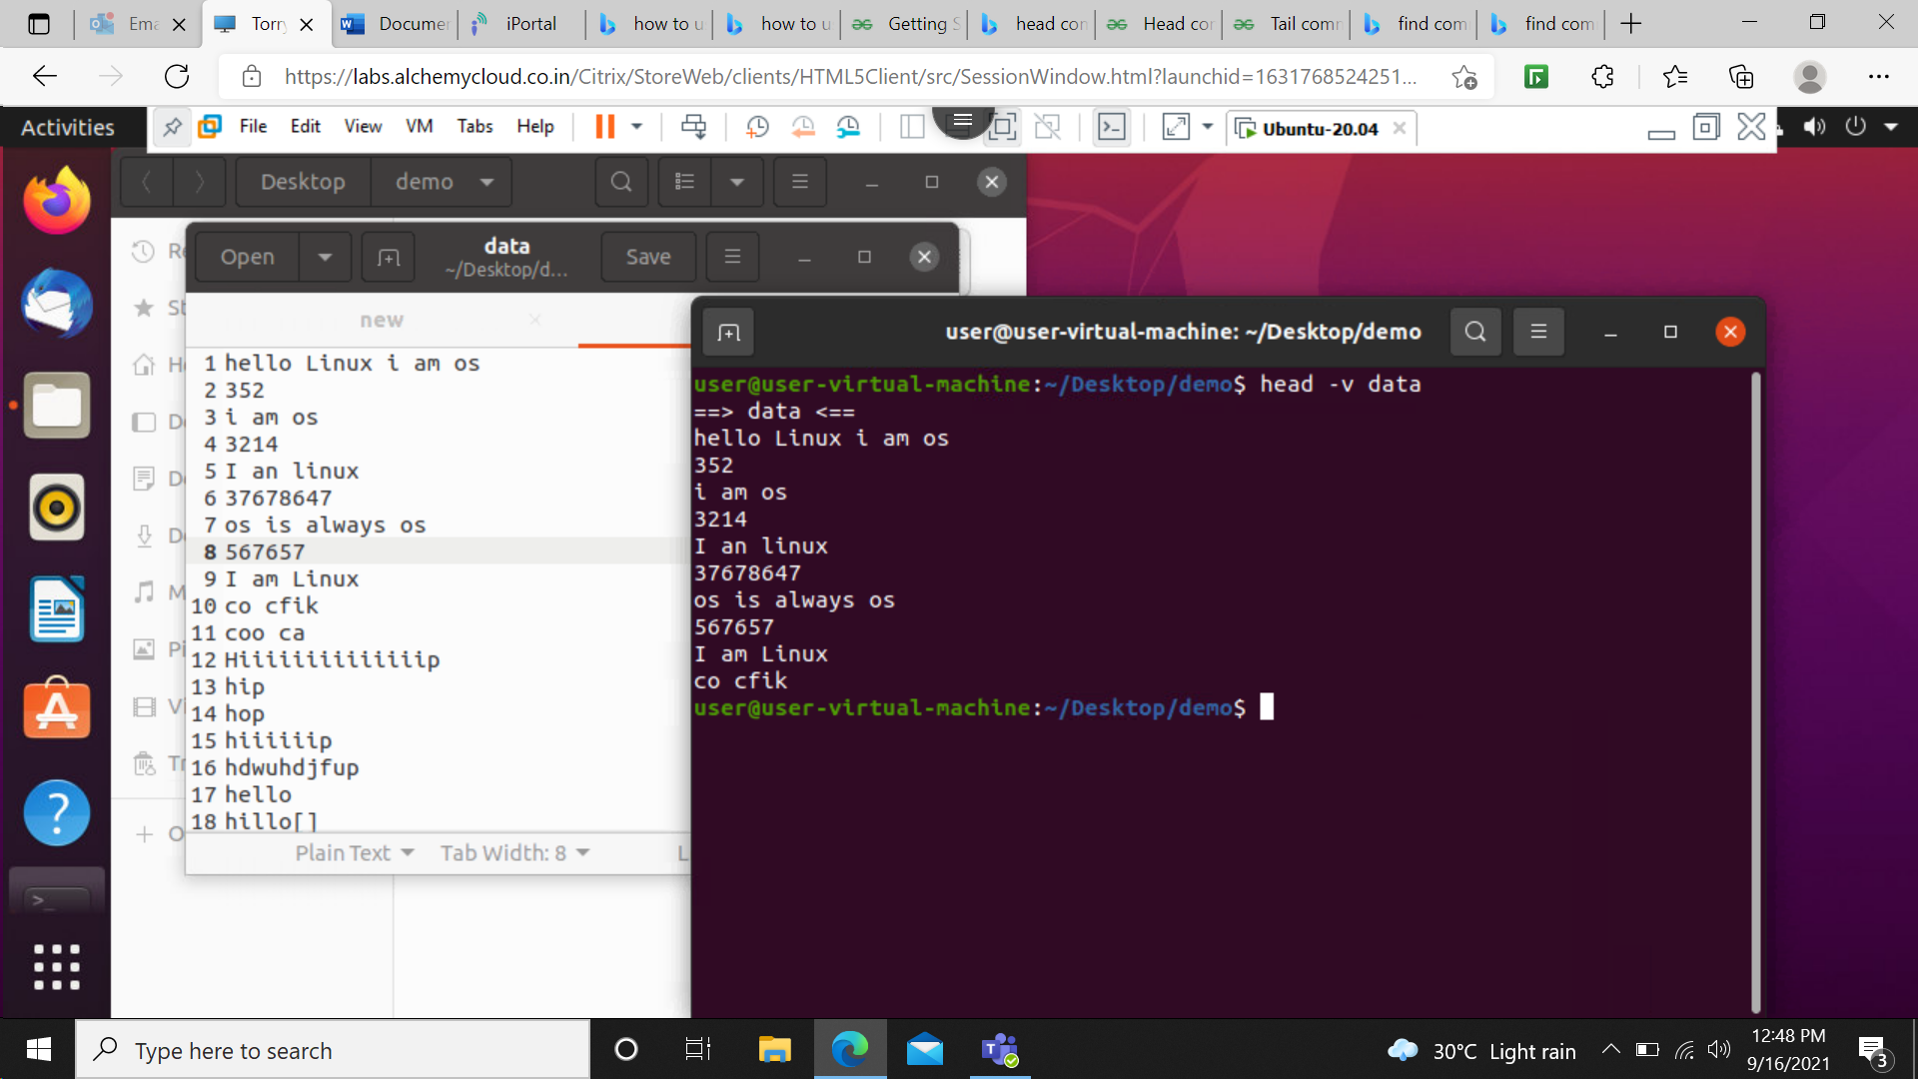

tail–n 3 data- This command is used to print the data of the file named data upto first 3 lines of the file from ending .

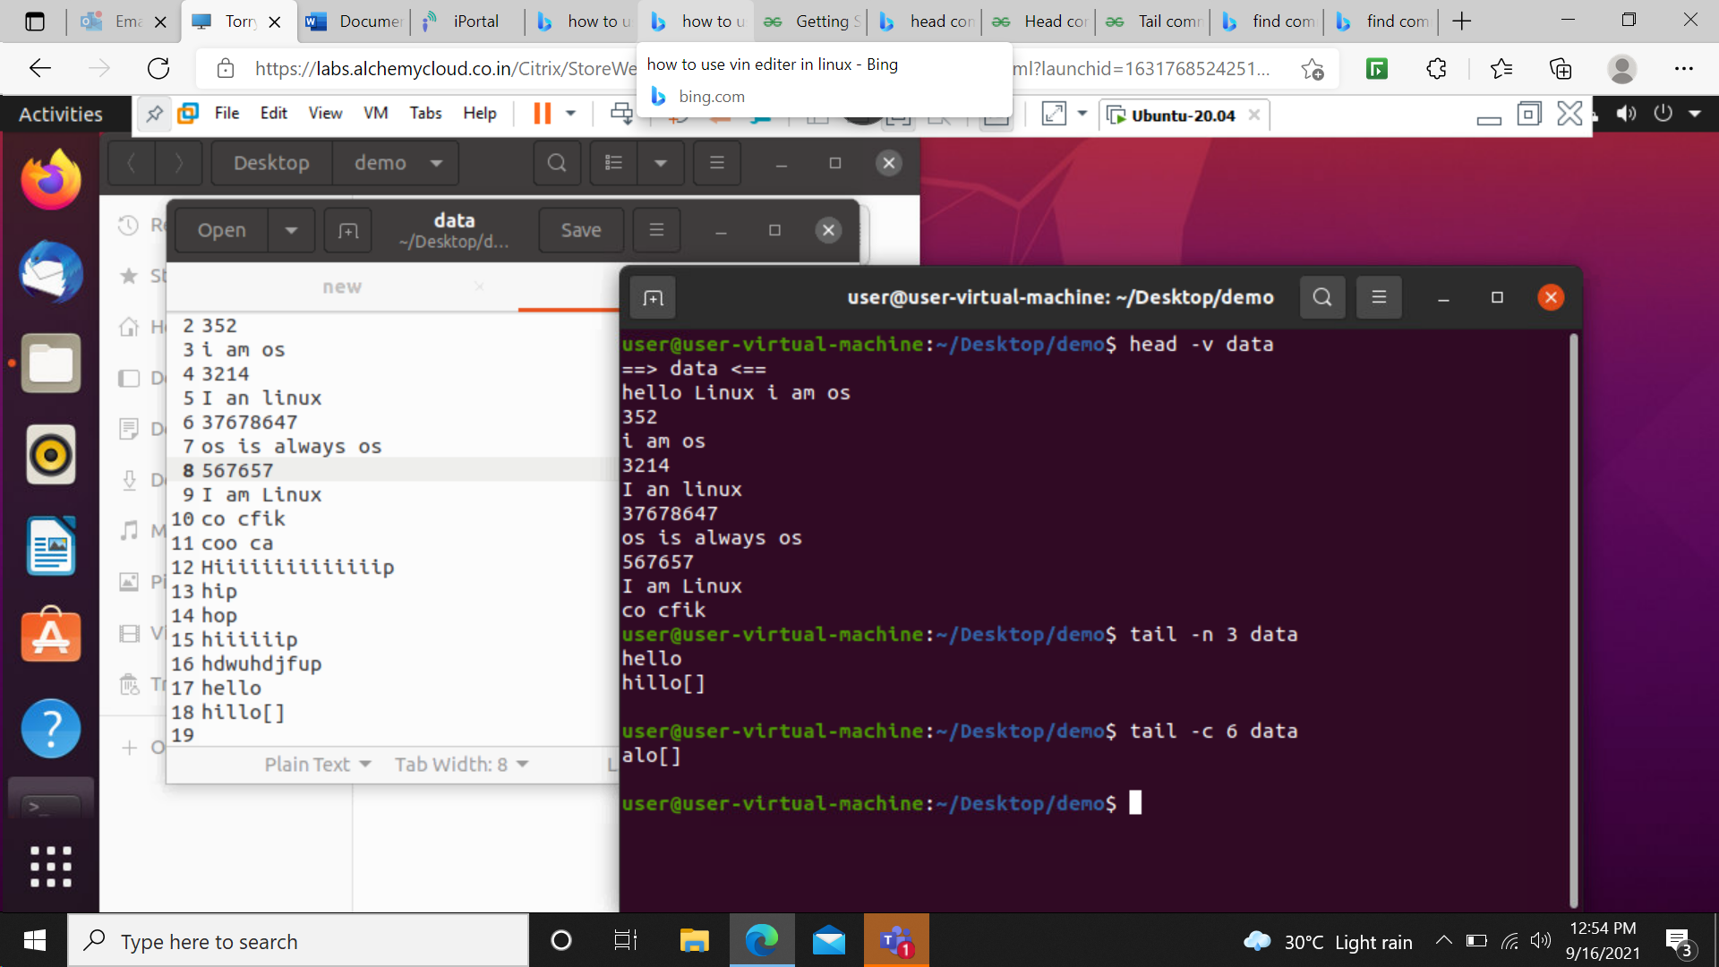

tail–c 6 data- This command is used to print firs 6 bytes if the line in the file named as data from Ending.



tail–q data new –This command is used to print the text inside the files named as data and new from ending.

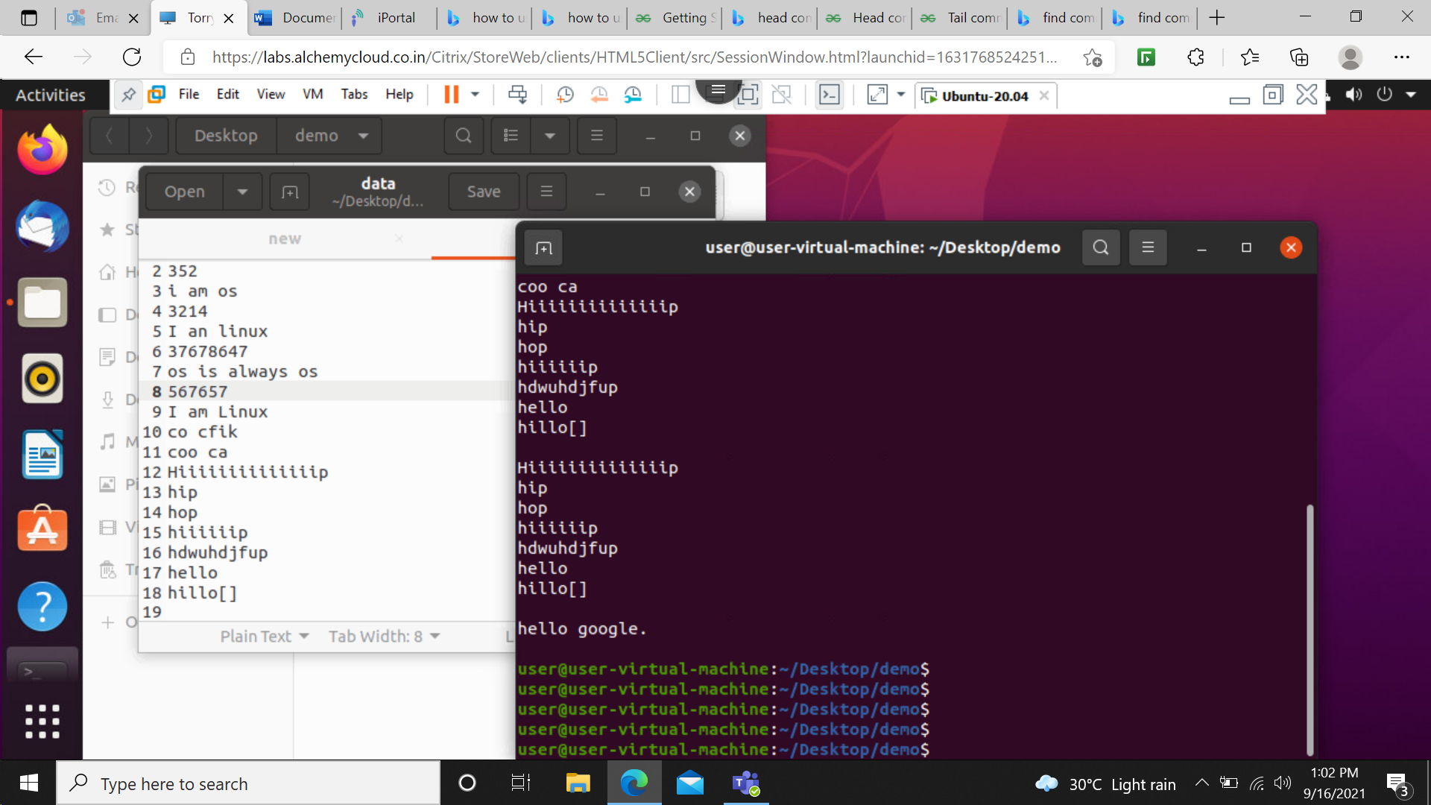

tail–v data- This command is use to print the name of the file and last 10 lines.

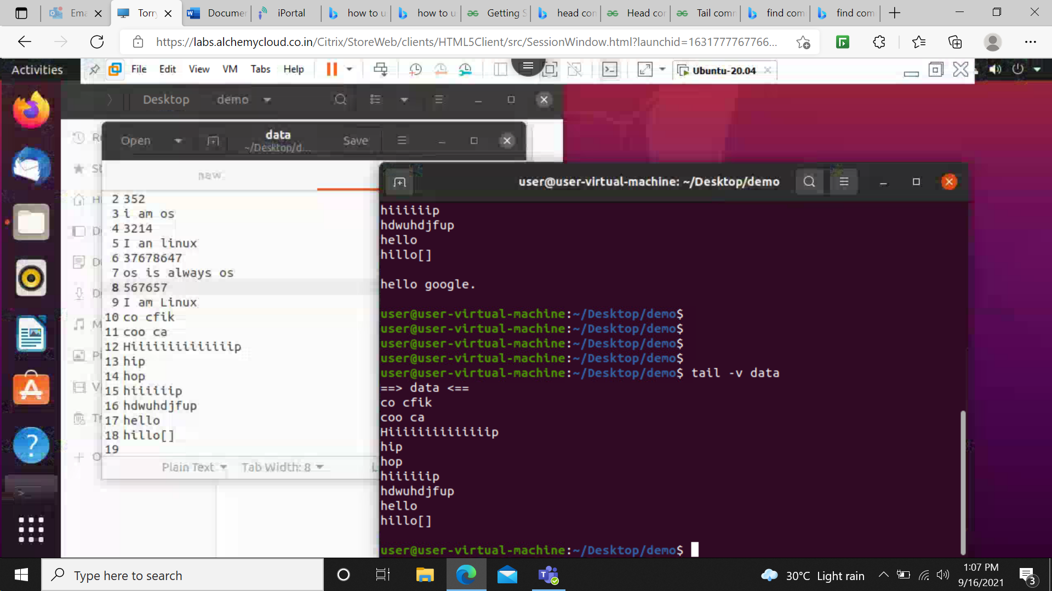

find –name data- this command shows the location of the file where it stored.

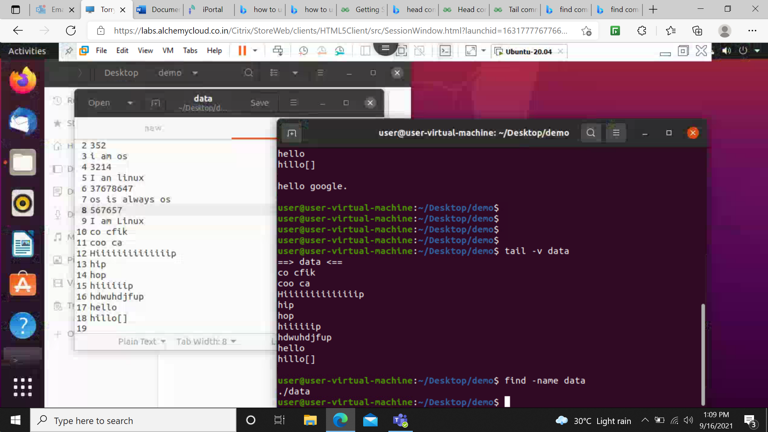

find .-type f- this command shows the the folders as well as files present in that location.

